Valley Life Athletics Gear Order Form
ORDER FORMS DUE FRIDAY, AUGUST 26ND!
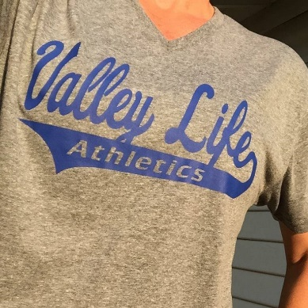
Unisex Tri-Blend V-Neck Shirt - $15 each
- X-Small
- Small
- Medium
- Large
- X-Large
- 2XL
QTY: __________
Total: ___________
Men’s Short-Sleeve T-Shirt - $15 each
- X-Small
- Small
- Medium
- Large
- X-Large
- 2XL
QTY: __________
Total: ___________
Youth Short-Sleeve T-Shirt - $12 each
- X-Small
- Small
- Medium
- Large
- X-Large
- 2XL
QTY: __________
Total: __________
*If you are ordering multiple items in one size, please note that next to the size. (For example, if I was ordering 3 small men’s short sleeve shirt, I would put a “3” next to the checked box for “small”)
Name: ________________________________________________
Phone Number (if we have questions): _______________________________________
Checks made to “Valley Life Foundation” or pay online at skooki.co or in the office through the kiosk. You will need to know your child’s student ID #, which the office can give you.

